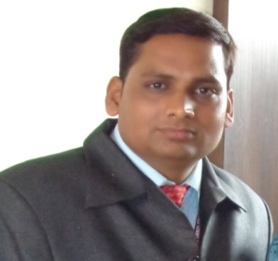

CONTEXT OF ACADEMIC BY H.O.D

The department of computer science was started in 2001 & is affiliated by
Pt. Ravishankar Shukla University (C.G). We provide various qualified and experienced faculties that has given various alumni who are place in various national, multinational industries & in bank sector as well. We provide quality education & our students respond in the same way. We have a gold medalist/merit student JEETENDRA KHEMANI,NEHA BERVE,MEGHA MISHRA,ANURADHA BAJAJ,PAWAN AHUJA & many more students which also have good academic marks. In spite of all these we also provide hardware add-on & personality development classes which helps our students to be more confident while facing the job interviews.

